Team 520 Operation Manual

Jason Goldstein, Lauren Roche, Sean Rodney, Valerie Rodriguez, Nicolas Sgammato
Department of Mechanical Engineering
Dr. Shayne McConomy
March 29th, 2024

Contents
Project Overview............................................................................................................................#
Component Description..................................................................................................................#
Integration.......................................................................................................................................#
Operation.........................................................................................................................................#
Troubleshooting..............................................................................................................................#
Appendix A: CAD Drawings..........................................................................................................#

Project Overview
This project's objective is to design an actively sealed coupler that prevents cryogenic fuel leakage during transfer from depot to vessel for future NASA missions. When developing a solution for this project, the main design priorities were for quick connection/disconnection and minimal leakage. Environmental considerations for lunar orbit were also taken into account for the material selection.
In order for the coupler to be actively sealed, no direct human interaction must be required for the sealing, connection, or disconnection of the coupler. Components such as a double poppet actuator, which allow for a quick connection and disconnection were incorporated into the coupler. Additionally, spring-energized Teflon seals similar to ones used by NASA are used in this design due to their high performance in cryogenic applications. Vacuum testing will be conducted to determine the coupler’s ability to minimize air leakage over a 24-hour period. Liquid nitrogen flow testing will also be conducted to ensure the system operates as intended under cryogenic conditions.
While fuel is transferred through the coupler, it is assumed that cryogenic fluid may come in contact with all system components. Fluids cooled to cryogenic temperatures have low boiling points which may cause changes in the properties of materials and components. The materials selected can endure the low temperatures while maintaining structural integrity and sealing capabilities. Liquid oxygen, a cryogenic propellant used by NASA, has a boiling temperature of roughly 90 K. Testing will be conducted with liquid nitrogen at 77 K which will verify that system materials can perform at the temperature of liquid oxygen.
The coupler is to be used for space missions meaning the system will need to withstand drastic changes in temperature. A 90-day lunar mission was the mission duration that the coupler was designed to complete. The lunar orbit temperatures, that can range from 140 - 400 K, and the effects of radiation were also considered. For testing there will be no insulation implemented but a spray on foam insulation on the outer surface is suggested due to its ability to minimize the heat flux from radiation.
The following sections outline the configuration and operation of the components of the coupler and the assembly of the parts. Due to the requirement for no human interaction, a testing mount was designed to ensure a constant force held connection. It is assumed that the pressure of the fuel tank in depot is equalized and that flow rates are low enough to create pressure losses within the coupler.

Component Description
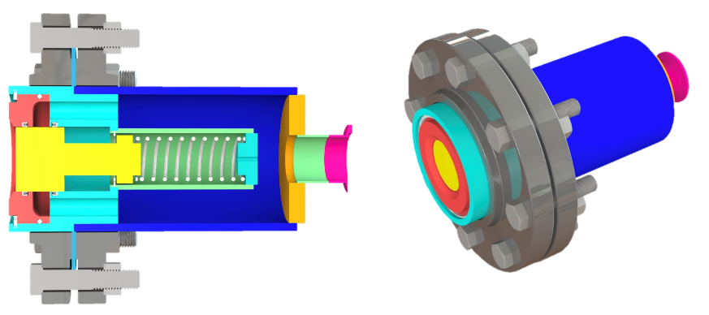
Figure 1: Receiver half cross-sectional view (left) and isometric view (right).
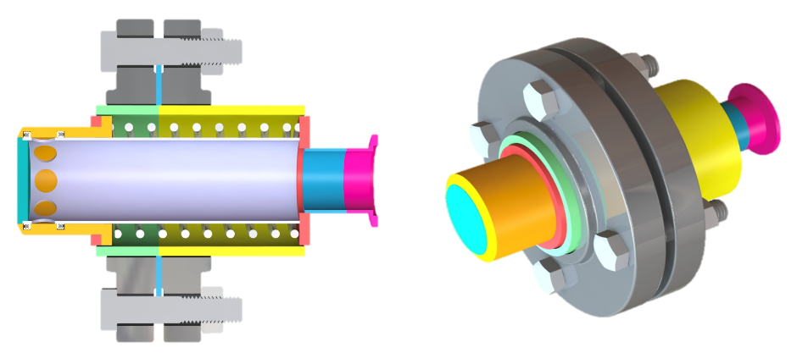
Figure 2: Probe half cross-sectional view (left) and isometric view (right).
The design consists of two major components, a receiver (Fig. 1) and probe (Fig. 2), seen in the image above. These two components are comprised of many smaller minor components that have been welded and assembled to make up each half. The coupler is designed such that in the de-mated position, both halves are closed and prevent fuel from flowing out. When mated, the poppet mechanisms on each side allow the springs to compress, aligning the flow channels enabling the fuel to flow from probe to receiver.
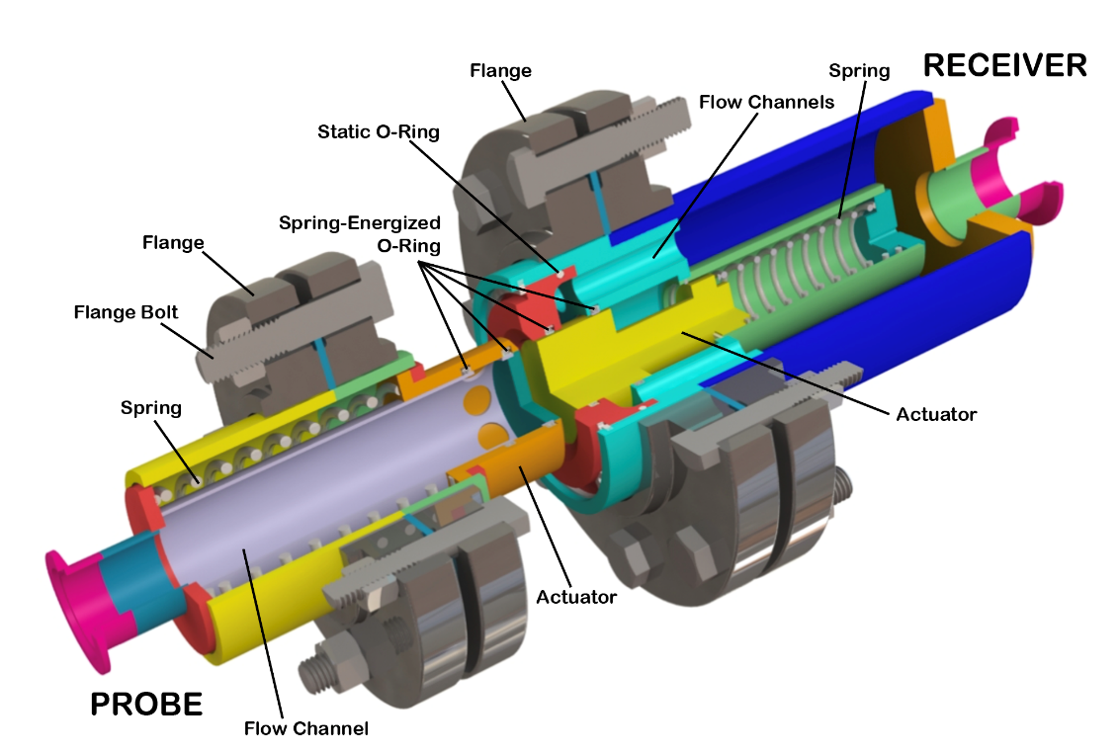
Figure 3: Isometric de-mated view with labeled main features.
The probe’s main components include a large central flow channel (where the fuel sits before it enters the receiver’s smaller flow channels) and an actuator with two embedded spring-energized O-rings that cover the holes to prevent leakage. The actuator is facilitated by the compression and decompression of the spring that sits between the flow channel body and the outer wall. For assembly purposes, this coupler half also features a flange with bolts.
The receiver’s main components also include a spring, actuator, spring-energized seals, and a flange. The spring exists in the inner compartment of the receiver body so both coupler halves fit together when mated. Instead of one large flow channel, this half features multiple small channels that eventually combine. Fuel flows through these channels and eventually, to a reservoir within the spacecraft. This design also uses a static O-ring to ensure sealing between the machined parts.

Integration
The design was modeled after and is meant to operate like a quick disconnect fitting commonly used in an air compressor. It should also be noted that the design was assumed to be fixed to a spacecraft structure, with the probe end being secured to a fuel depot station and the receiver fixed to a mobile spacecraft. However, the coupler can still be manually operated if it is not fixed to these structures. Due to the force required to compress each spring in the probe and receiver as well as the weight of the coupler, it will likely require the operator to make a fixture that allows for forceful mating and compression of the springs. This can be done by fixing an external feature on the flange surfaces that brings the two halves closer together to the point of the mated position. Clamping mechanisms like a bar clamp should be considered.

Operation
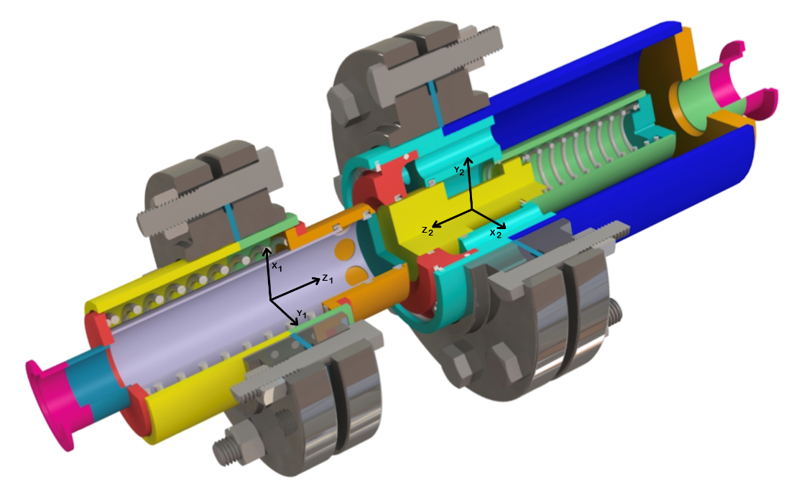
Figure 4: Local coordinate system of probe half (left) and receiver half (right).
This coupler is intended to be used by trained spacecraft pilots, comfortable with precise positioning. During mating, the pilot will position the craft to align the z axes (z1 and z2 on Fig. 4) of the receiver and probe. Slight misalignment in this axial direction can be tolerated but is not encouraged due to material wear. Alignment of the x-y planes is not needed; design will allow for flow in any x-y orientation. The pilot must then push the craft forward in the positive z2 direction to connect both halves. The de-mating process requires the pilot to reverse this motion, moving away in the -z2 direction.
Though a standard receiver-driven operation is described here, the coupler can be mated using a probe-driven or probe-and-receiver-driven connection; the relative motion between both halves does not impact functionality.

Troubleshooting
If any internal or external leaks are found after use, it is important to check for material wear and friction damage to the O-rings. An endoscope may be inserted into the flow channels on the probe or receiver end to visually detect any cracking within the coupler without disassembly. With this method, the user should inspect the joints and walls for signs of cracking and deformation that may result from high impact or misalignment during mating. Depending on the location and severity of the issue, disassembly of the coupler may be required. If the spring-energized O-rings have any signs of wear, they will need to be replaced. Wear can be checked by pushing back the actuator and noting signs of material degradation. Static O-ring replacement requires disassembly of the coupler.

Appendix A: CAD Drawings
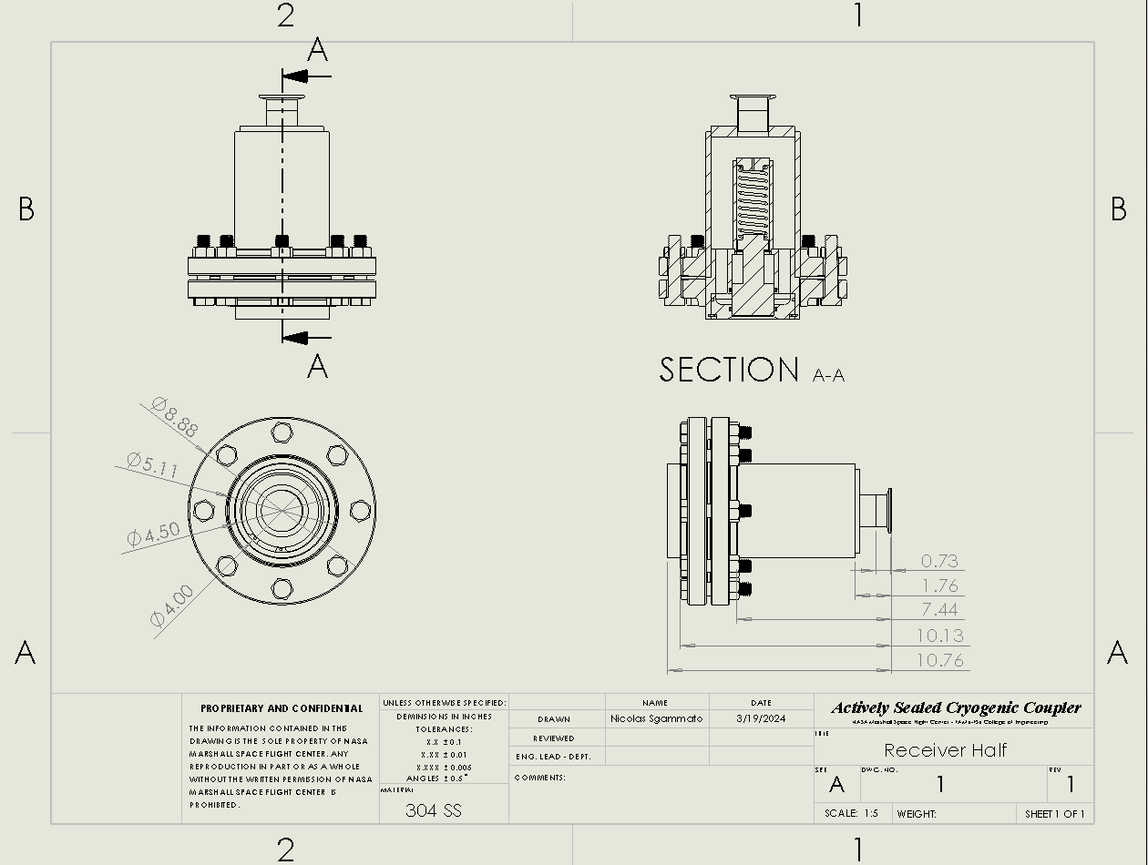
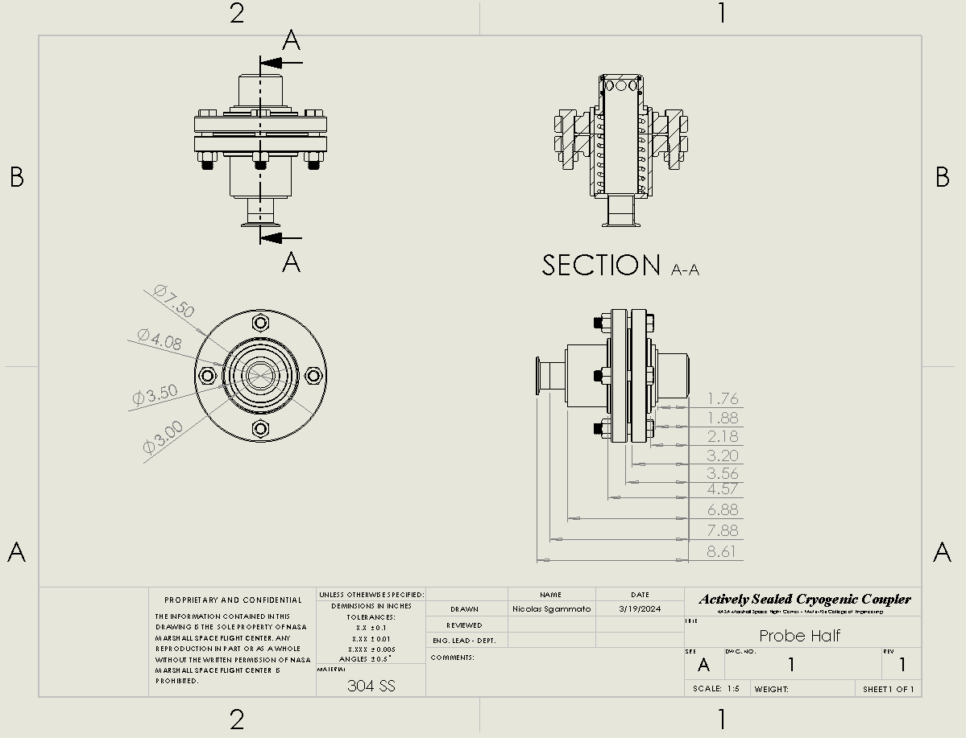
Receiver Assembly Drawing with Basic Dimensions
Probe Assembly Drawing with Basic Dimensions

